Protein Synthesis

Protein synthesis occurs in two stages:
- Transcription inside the nucleus.
- Translation inside the cytoplasm.

Transcription

This is where the code for a polypeptide is copied from the DNA to mRNA.

- The DNA unzips the required gene.
- Complementary RNA nucleotides (that were floating freely in the nucleus) join up to the antisense strand of the DNA with hydrogen bonds.
- RNA polymerase joins the nucleotides by phosphodiester bonds in a condensation reaction.
- mRNA detaches from the DNA, then leaves the nucleus.
- The DNA re-zips.

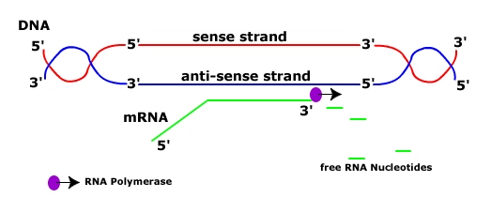

Translation

This is where the ribosome interprets the mRNA to that amino acids are linked together to form the correct polypeptide.

